**Digital Electronics Project Report 3**

**Team Members**: 110122020

110122040

110122070

**Thus far**:

1. We setup a Demux coupled with the Mux and gave sine wave as an input to the mux.
2. The output of the Mux was connected to input of the Demux.
3. The selecting lines were given with the same input.
4. The output was analysed with the oscilloscope whether the sine wave input and the output were resembling same or not.
5. Figured out the reason why it was not working with analog signals as it we were not using analog mux.

**The file is attached below**:

The Analog **Mux** and **Demux** used here is **4051 IC** with an oscilloscope simulated on proteus.

**Next Step**:

* + Implement the same in hardware.
  + Simulating a 16:1 Mux and Demux to verify its working.

The Circuit Diagram is as shown in the Figure below:

* The sine wave is given with a frequency of 200 Hz while the selecting lines frequency is given 400k,200k,100k Hz
* We have used 2 DSO to observe the output of the Demux and have attached the same to the file
* The output wave form comes as a sine wave showing that the multiplexer works when the input signal is sine wave with a frequency of 1Hz and amplitude ranging from 1 to 128 respectively.

There is a 0.01ms delay in the switching speed which is observed.

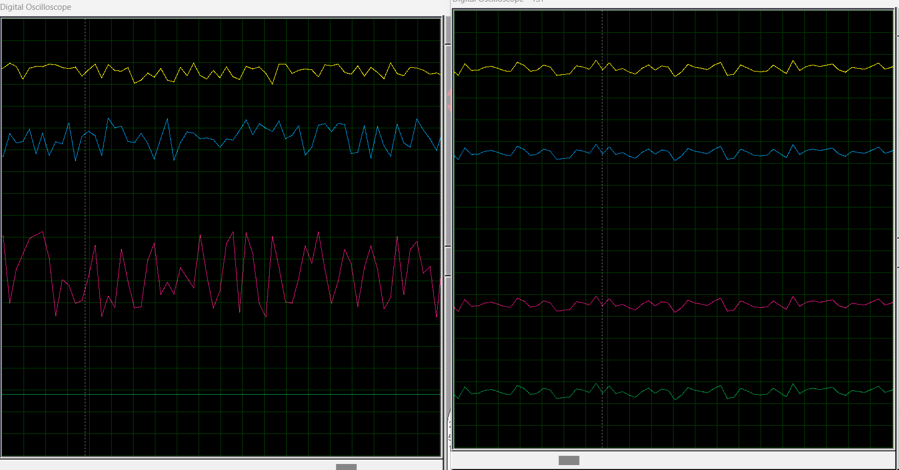

This is the ouput got for the given random input given on the right side.